# **How to Use a Photoresistor (or Photocell) in Arduino:**

A photoresistor or photocell is a light-controlled variable resistor. The resistance of a photoresistor decreases with increasing incident light intensity. A photoresistor can be applied in light-sensitive detector circuits, and light- and dark-activated switching circuits. It's also called light-dependent resistor (LDR).

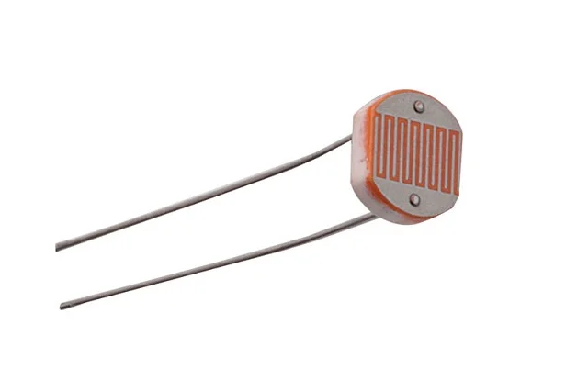

## **How to Use Photoresistor**

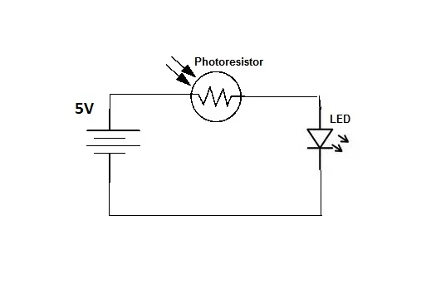

Let's see how a photoresistor react in light. Build the circuit above and notice how led brightness change.

The resistance value becomes smaller when there is much light in the room. So in the dark the led remains off because the resistance has become very big.

The Arduino will help us to reverse this situation, let's see how in next step.

## **The Circuit:**

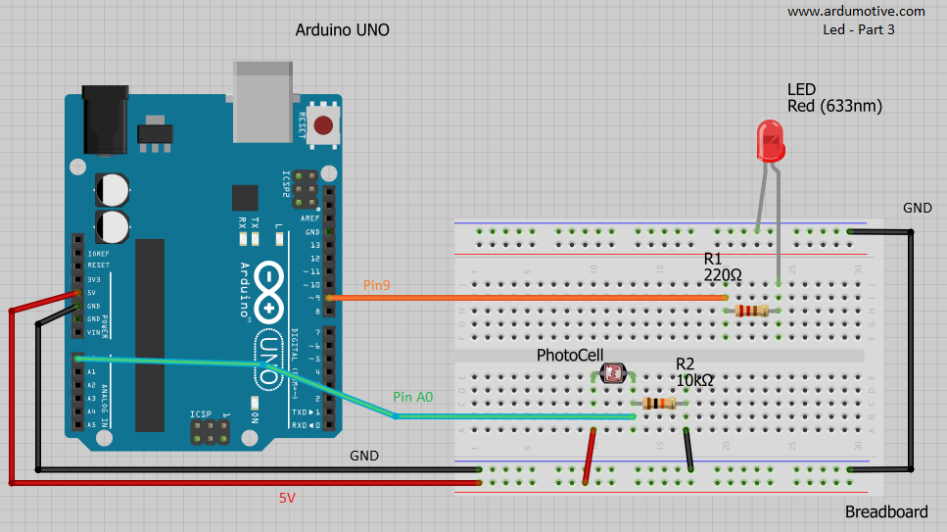

You will need:

* Arduino uno
* Breadboard
* LED
* 220 Ohm & 10 KOhm resistors
* Photoresistror

## **The Code:**

const int pResistor = A0; // Photoresistor at Arduino analog pin A0

const int ledPin=9; // Led pin at Arduino pin 9

//Variables

int value; // Store value from photoresistor (0-1023)

void setup(){

pinMode(ledPin, OUTPUT); // Set lepPin - 9 pin as an output

pinMode(pResistor, INPUT); // Set pResistor - A0 pin as an input (optional)

}

void loop(){

value = analogRead(pResistor);

//You can change value "25"

if (value > 25){

digitalWrite(ledPin, LOW); //Turn led off

}

else{

digitalWrite(ledPin, HIGH); //Turn led on

}

delay(500); //Small delay

}